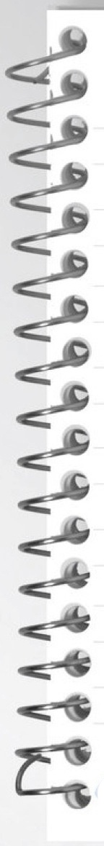

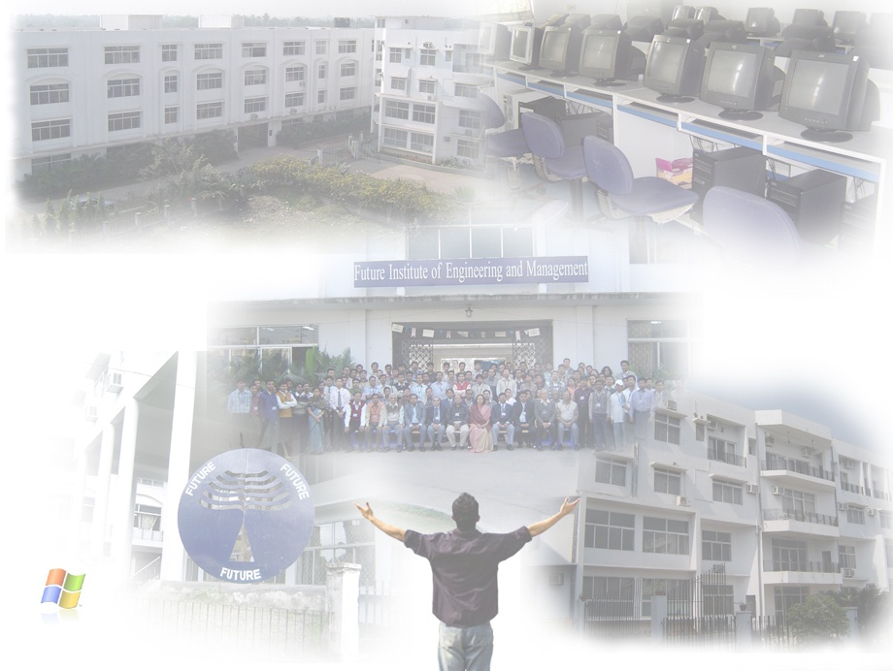

**Data Structure and Algorithm Lab (C) - PCC-CS391**

**REPORT ON:** …………………………..………………………………………………………………Lab.

**ARNA CHAULIA**

**NAME:** …………………………………………………………………………………………………………..

**COMPUTER SCIENCE & ENGINEERING**

**DEPARTMENT:** ……………………………………………………………………………………………..

**3RD**

**22/CSE/052**

**CSE-II**

**C**

**ROLL NO: .**……………..….…… **SEM:** …….…….… **GRP:** ….…… **SECTION:** ……..........

**3a , 3b**

**III**

**ASSIGNMENT NO:** ………..……**PROGRAM NO:** …..………………………………………....



**TITLE / OBJECTIVE:**

**IMPLEMENTATION OF QUEUE DATA STRUCTUREs**

**QUEUE OPERATIONS :   
1. Enqueue**

1. **Dequeue  
   3. Display**

.…………………………………………………..…………………………………..................................

……….………………………………………………………………………………..................................

………….……………………………………………………………………………..................................

………….……………………………………………………………………………..................................

………….……………………………………………………………………….…….................................



……….………………………………………………………………………………..................................

………….……………………………………………………………………………..................................

………….……………………………………………………………………………..................................



**05/10/2023**

**12/10/2023**

**PERFORMANCE DATE:** …....……………….. **SUBMISSION DATE:** ………………….......

**EXAMINER’S SIGNATURE:** ……………………………………………………………………………..